Concept Submission Form

The aim of this concept document is simple. To put forward an idea that is interesting or promising enough to pursue – more interesting and more promising than any other ideas that we have.

The concept should focus on what the player does, and why this is good (where applicable obviously). This is far more important than working out the names of the main protagonists, or the reason why the player chose the red pill in the back story. What the player does, and the major features of the game are what differentiates an initial idea, not the back story. Obviously if the story is key to the game, then it’s worth mentioning, but the decision to pursue a concept or not is likely to be based on the quality of the game itself, rather than a “wrapper”.

Concept Name

Planet Furgle-gloop

Concept Platform

PC

Concept Constraints

Since we have 12 months to complete this task, its possible some mechanics may not get implemented, since we are all on the game development course we have no experience / modules involving art design so some issues may arise if the game is too visual, if visual aid is essential however basic templates may be used instead. Our group has little experience with Unity and thus we will need to spend time learning the engine which could reduce the amount of time we can work on the actual game, mechanics may also be an issue once we acknowledge our limitations.

Submitter

Alex Jones (18085539)

Key Target
The game rules were set out to be bi-lingual meaning anyone can play it, this gives us many new restraints, as many games explain tutorials through audio or text so we need to discover another way to communicate the basics to the user.

Brief Description

3D puzzle/memory game, you crash your spaceship and come into contact with alien creatures that communicate via body language, you must copy their moves in order to show you are not a threat, if you are successful you can move past the aliens without any damage and pick up / recover parts from your ship to repair the damage.

Key Features

A space exploration game, the player must remember how to communicate to each alien they encounter, while avoiding dangers the environment has to offer.

Additional Selling Points

Controls are set up by the player when they start the game and therefore they must remember what each button does, if they see a red alien they must hit the red alien body language button and same case for blue etc. A brief video could also be displayed showing what is expected of the player before the level starts.

Reference

Spore, super Mario advanced, Simon says.

Comments
As a visual aid, this is what I am implying before the game starts.
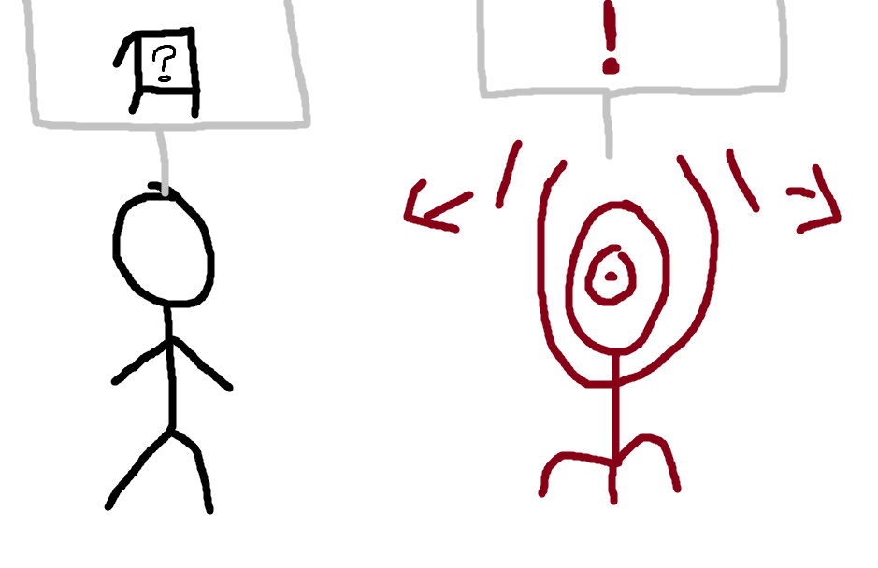
? implying whatever button they hit, it will be assigned to the red alien.

